CIS 357

Lab 5

Rodney Fulk

Taylor Euwema

Matthew Hoffman

Jason Carr

**Step 4:Verifying if there is a connection already established between the repeater and the root AP by now**

**Q-1: Record the association info and submit a screen capture for the above command’s output.**

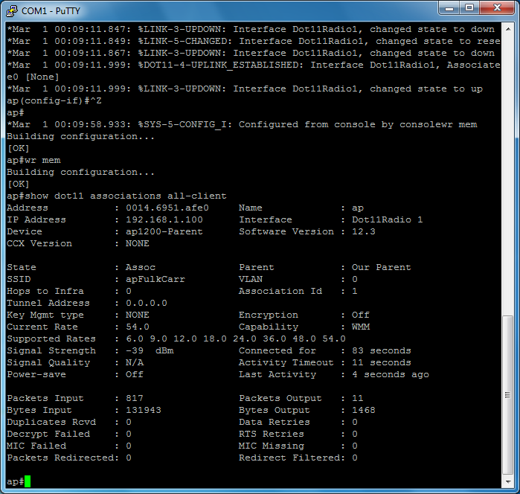

**Q-2: Record the output of the 2 ping commands**

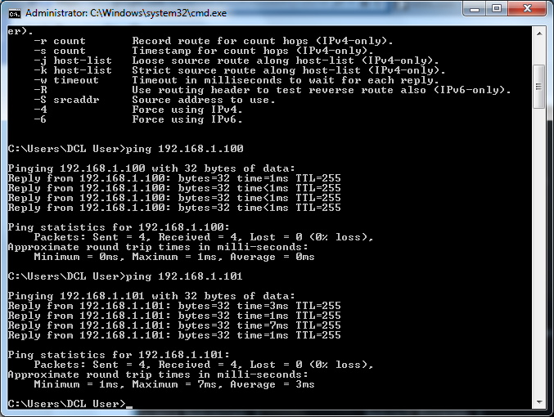

**Q-3: Submit a screen shot for the running configs on the 2 APS**

**Repeater:**

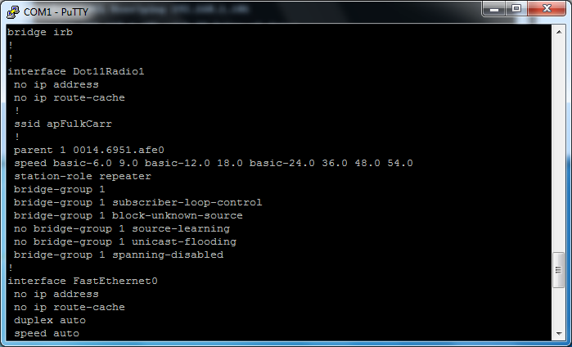

**AP:**

